Part A) Please review code. Eb/No Calculation has been developed and used to calculate the G-Factor

Part B) 2-D Image Displaying color vs Eb/No neglecting Interference

Figure 1

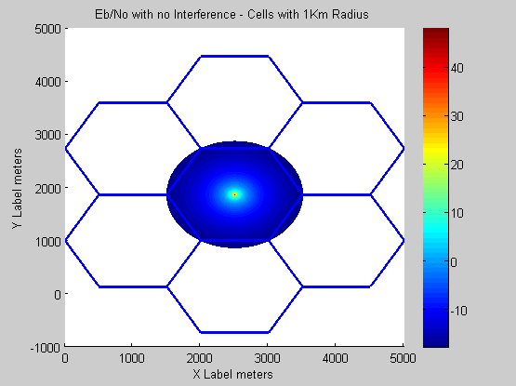

Figure 2

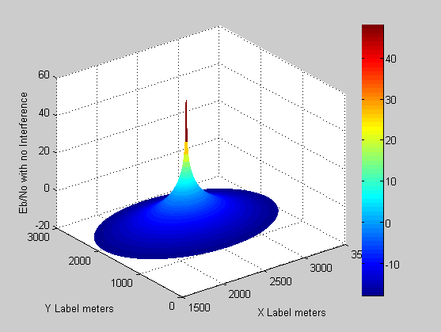

Part C) Using a histogram approximation to the probability density function, generate a method that plots the cumulative distribution function (CDF) of the (Eb/No)dB within the target cell assuming users are uniformly distributed in the 2-Dim cell space, neglecting the Interferences (e.g. use SNR, not SNIR).

Figure 3.

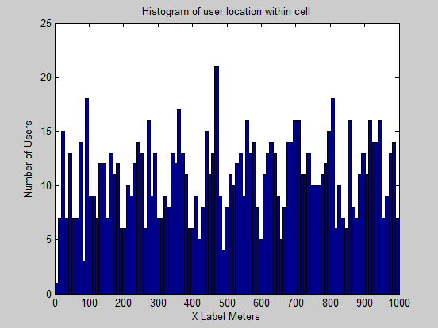

Figure 4.

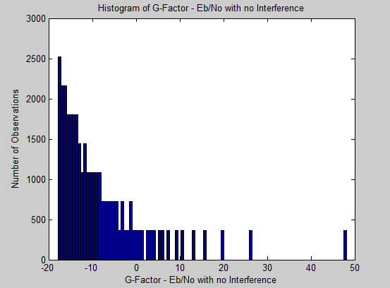

Figure 5.

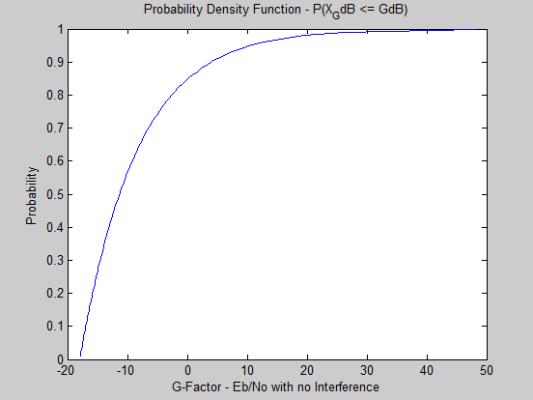

Part D) Generate a 2-Dim image display which illustrates color versus Eb/No, accounting for interference and a cell-reuse of 1. For this this case use SNIR=S/(N+I).

Figure 6.

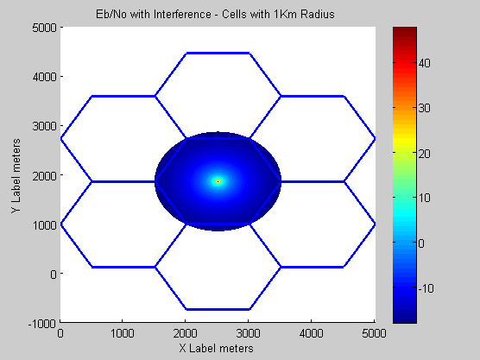

Figure 7.

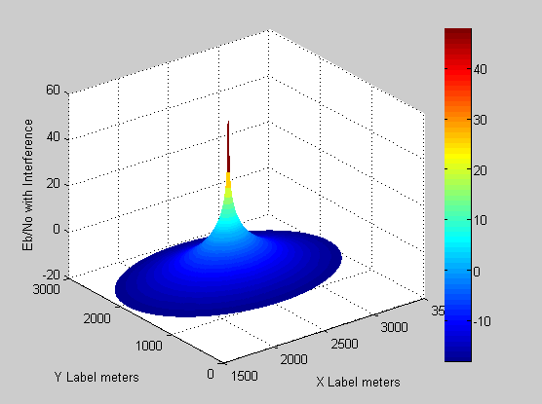

Part E) Using a histogram approximation to the probability density function, generate a method that plots the cumulative distribution function (CDF) of the (Eb/No)dB within the target cell assuming users are uniformly distributed in the 2-Dim cell space, accounting for interference and a cell-reuse of 1. For this this case use SNIR=S/(N+I).

Figure 8.

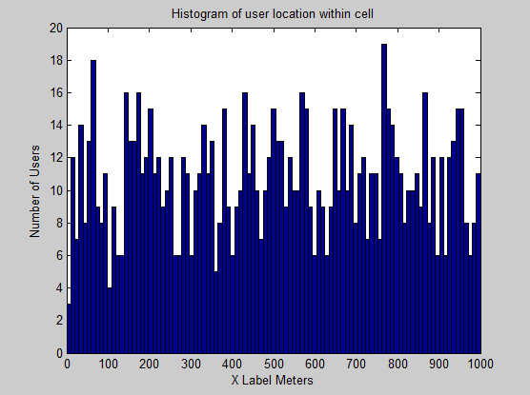

Figure 9.

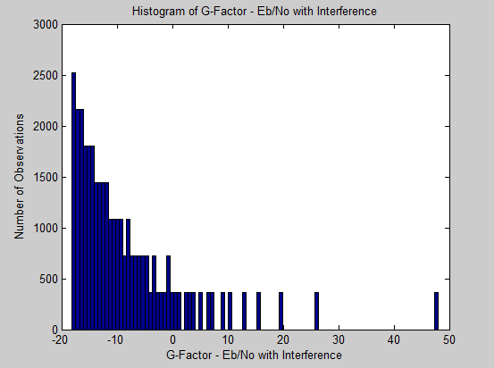

Figure 10.

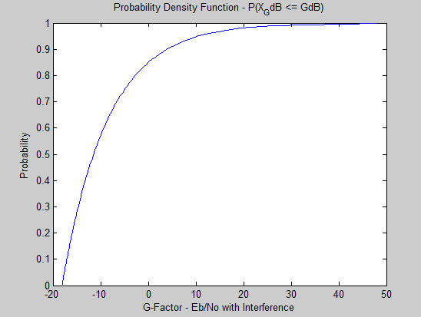

**Key Notes**

Eb/No with **NO** Interference

Max (Eb/No)dB : 48.1431

min (Eb/No)dB : -17.8569

Eb/No with Interference

Max (Eb/No)dB : 48.0175

min (Eb/No)dB : -18.0428